Assessment of interaction of pathogenic bacteria on antifouling polymer brushes via Atomic Force Microscopy

Abstract: Hydrophilic polymer brushes have been shown to reduce the protein adsorption even from complex biological media, thus preventing the formation of a conditioning coating associated with the initial adhesion of bacteria. Some bacteria, however, are able to attach to surfaces even if these conditioning coating is prevented, thus the mechanisms of bacteria adhesion remain elusive. This STSM aimed at (i) studying the mechanical properties of ultra-thin polymer brushes by force spectroscopy and (ii) assessing the interaction of pathogenic bacteria with the same antifouling brushes prepared at my group. The adhesion of Yersinia was measured via single cell force spectroscopy (SCFS) by immobilizing a bacterium to a cantilever equipped with a silicon ball. Evaluation and comparison of the force curves for different polymer brushes enabled us to identify differences in adhesion on different antifouling surfaces.

Background and purpose
Bacterial colonization of surfaces and interfaces has a major impact on various biotechnological areas. Some of the various detrimental effects include accelerated corrosion of metals (biocorrosion),¹ contamination of food causing food spoilage or posing serious risks to public health as well as infections and sepsis due to bacteria adhered to implants.²⁻⁵ Bacteria rapidly adhere to the surfaces and in some cases form a biofilm which leads to an increased adhesion and resistance to antibiotics. It has been postulated that development of biofilms occurs in several steps: (i) the formation of a conditioning film either from components of the media in contact with the surface or by the EPS generated by the bacteria, (ii) subsequent transport of the bacteria towards the substrate and (iii) adhesion.
Bacterial adhesion can be prevented by minimizing the forces driving the bacterium into contact with the substrate. For the coating to be effective no primary nor secondary adsorption can be allowed, i.e. the coating should be homogeneous without pin-holes enabling direct contact with the substrate.
Despites, the growing research in the field of antibacterial surfaces as well as biofilm biology, surfaces with long term resistance to biofilm formation remains elusive. Recently we showed the resistance to the formation of biofilm from laboratory and environmental strains of Pseudomona aeruginosa (P. aeruginosa) on two ultra-low fouling polymer brushes, poly[oligo(ethylene glycol)methyl ether methacrylate] (poly(MeOEGMA)) and poly[N-(2-hydroxypropyl)methacrylamide] (poly(HPMA)). P. aeruginosa is one of the most common opportunistic pathogens causing nosocomial infections.⁶ However, different mechanisms of adsorption of these bacteria and others remain unexplored.
The goals of the proposal were (i) to study the mechanical properties of ultra-thin polymer brushes by force spectroscopy and (ii) to assess the forces supporting the initial steps of bacteria adhesion and to compare the interaction of bacteria with 7 different antifouling (Figure 1). The results can be used to understand the mechanisms of resistance to bacteria fouling on various brushes.
Figure 1. Scheme of antifouling polymer brushes proposed for the study (A) and schematic representation of polymer brushes grown on a cover slip to be probed by a bacterium on a colloidal probe cantilever (B).

Research tasks and results
Firstly topographic images were performed on the seven polymer brushes prepared: oligo(ethylene glycol) methyl ether methacrylate (MeOEGMA), oligo(ethylene glycol) methacrylate (HOEGMA), carboxybetaine (meth)acrylamide, sulfobetaine methacrylate, phosphorylcholine methacrylate and N-(2-hydroxypropyl)methacrylamide. All the images were taken with the brushes in their swollen state in phosphate buffered saline (pH ., no Ca⁺² nor Mg⁺²). All brushes were homogeneous without any pin-hole which could lead to primary adhesion, i.e. direct interaction with the surface. The brushes based on poly(PCMA) showed markedly different surface organization, not observed on any of the other brushes.
Using the QI mode from JPK nanowizard, force curves were obtained from each surface identifying key difference between brushes. The force mapping carried out using a microcantilver (Olympus) and a colloidal probe cantilever previously calibrated. The differences in adhesion to the colloidal cantilever can be correlated with the chemical composition of the lateral chains of the brushes. Important interaction of the brushes having hydroxyls groups was observed using the colloidal probe.
The adhesion of Yersinia pseudotuberculosis was assess by SCFS using a Bruker catalyst AFM. A single bacterium was fixed on a colloidal probe cantilever precoated with a wet adhesive based on freshly polymerized poly(dopamine) as described before.⁷ The adhesion was measured on various common surfaces such as polystyrene petri dishes, glass, Teflon as well as on polymer brushes. Representative curves are shown in figure 2. While all the surfaces not protected with brushes showed a marked adhesion of the bacteria, the brushes based on poly(HOEGMA) and poly(HEMA) shows a marked reduction of the adhesion. Negligible adhesion, was observed when the brushes were based on a zwitterionic polymer and on poly(HPMA). Remarkably, these results correlate with the previously observed level of resistance to fouling.

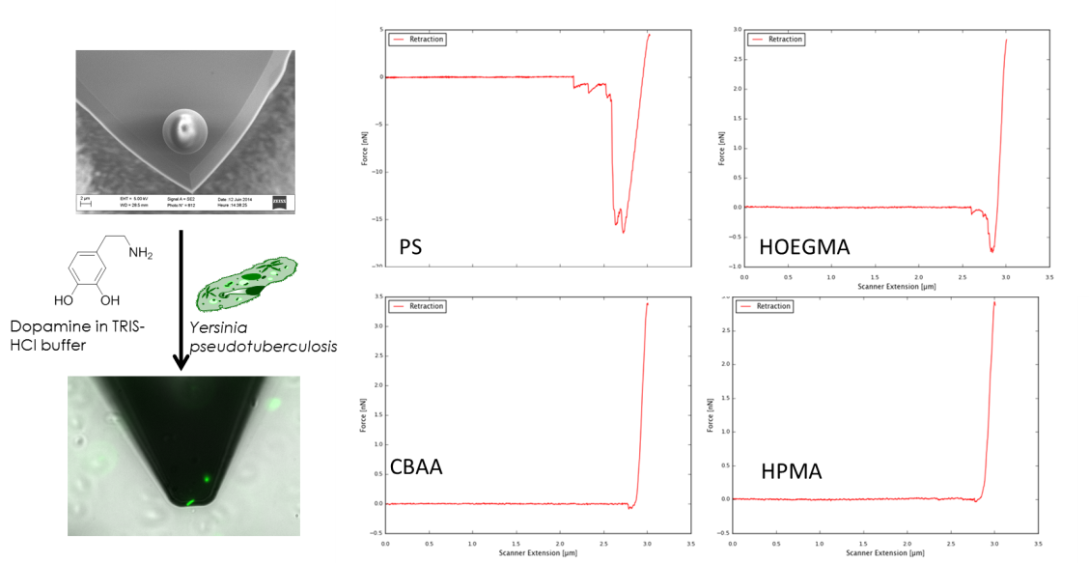
Figure 2. Functionalization of the colloidal probe cantilever and characteristic single cell force spectroscopy curves on polystyrene, and 3 types of brushes.
Outcomes
As a direct outcome of this STSM two scientific communications in referee journals will be published. In addition the stay at Prof. Lafont’s group provided the candidate with valuable learning experiences and with the possibility to start a collaboration between his junior group and Prof. Lafont.
Future collaboration
Based on the obtained results further joint work with Prof. Lafont’s group has already been planned on the field of chemical force spectroscopy of various brushes.
References
(1). Yuan, S. J.; Pehkonen, S. O.; Ting, Y. P.; Neoh, K. G.; Kang, E. T., Langmuir 2010, 26, 6728-36.
(2). Kingshott, P.; Wei, J.; Bagge-Ravn, D.; Gadegaard, N.; Gram, L., Langmuir 2003, 19, 6912-6921.
(3). Darouiche, R. O., N. Engl. J. Med. 2004, 350, 1422-1429.
(4). Stickler, D. J., Curr. Opin. Infect. Dis. 2000, 13, 389-393.
(5). Hasan, J.; Crawford, R. J.; Ivanova, E. P., Trends Biotechnol. 2013, 31, 295-304.
(6). Rodriguez-Emmenegger, C.; Decker, A.; Surman, F.; Preuss, C. M.; Sedlakova, Z.; Zydziak, N.; Barner-Kowollik, C.; Schwartz, T.; Barner, L., RSC Advances 2014.
(7). Beaussart, A.; El-Kirat-Chatel, S.; Sullan, R. M. A.; Alsteens, D.; Herman, P.; Derclaye, S.; Dufrêne, Y. F., Nat. Protocols 2014, 9, 1049-1055.

